Jawaban

1)

<?php

for ($a = 0; $a <= 100 ; $a++) {

$b = 0;

for ($c = 1; $c <= $a; $c++) {

if ($a % $c == 0) {

$b++;

}

}

if ($b == 2) {

echo $a. "," . " ";

}

}

?>

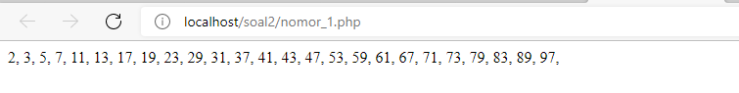

2)

<?php

for ($a = 1; $a <= 100 ; $a++) {

if($a%2==1){

echo $a.",";

}

}

?>



3)

<?php

for ($a = 1; $a <= 100 ; $a++) {

if($a%2==0){

echo $a.",";

}

}

?>



4)

<?php

$a_awal = 0;

$a_akhir = 1;

$output ="";

echo $a_awal.' '.$a_akhir.' ';

do{

echo $output.' ';

$output = $a_akhir + $a_awal;

$a_awal = $a_akhir;

$a_akhir = $output;

}

while ($a_akhir<=100)

?>

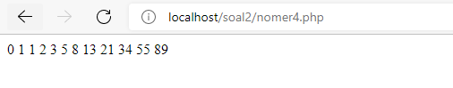

5)

<?php

$uang = 850000;

$bunga = 5/100;

$hasil = $uang * $bunga ;

echo "Bunga yang di dapat Heru adalah Rp ".$hasil;

?>



6)

<?php

$sepatu = 165000;

$discont = 15/100;

$uang = 150000;

$total_discont = $sepatu * $discont;

$harga_discount = $sepatu - $total_discont;

$kembalian = $uang - $harga_discount ;

echo "Kembalian yang di terima Ilham sebesar Rp ".$kembalian;

?>



7)

<?php

$gros=144;

$lusin=12;

$jml_piring = 6*$gros;

$pinjam_tio = 4*$lusin;

$pinjam_david = 2*$gros;

$sisa_piring = $jml_piring-$pinjam_tio-$pinjam_david;

echo "Sisa piring Vikrie sebanyak ".$sisa_piring;

?>

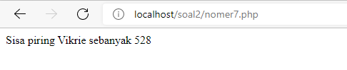

8)

<!DOCTYPE html>

<html>

<body>

<h1>Belanja Hafid</h1>

<form action="nomer_8.php" method="post">

<table>

<tr>

<td>Masukan Jumlah Uang</td>

<td><input type="text" name="uang">

</tr>

<tr>

<td rowspan="2"><input type="submit" value="cek"></td>

</tr>

</table>

</form>

</body>

</html>

File nomer_8.php

<?php

$jas=750000;

$celana_panjang=350000;

$kameja=225000;

$kaos=100000;

$celana_pendek=50000;

$uangditerima=$_POST['uang'];

if($uangditerima>=$jas){

echo "Mendapatkan Jas";

}else if($uangditerima>=$celana_panjang){

echo"Mendapatkan Celana Panjang";

}else if($uangditerima>=$kameja){

echo"Mendapatkan Kameja";

}else if($uangditerima>=$kaos){

echo"Mendapatkan Kaos";

}else if($uangditerima>=$celana_pendek){

echo"Mendapatkan Celana Pendek";

}else {

echo"Tidak Mendapat apa apa";

}

?>

